LGE Internal Use Only

LGE VS [OEM NAME] [PROJECT NAME]

Software Unit Test Plan (SWUTP)

About This Template
- Template Name: LGE_VS_SWIT_T01_SWUTP(Software Unit Test Plan)
- Management Department: VS SW Process Team
- Revision History
Version | Date | Comment | Author
2.0 | 2017-10-16 | Initial Release  - Modified from LGE_VC_Template_TMP(Test_Master Plan_v1.0 to comply with A-SPICE 3.0 and ISO 29119 | VC Smart SW Process Team  LG Electroincis
2.1 | 2019-03-08 | Update due to annual organization restructuring (VC --> VS) | VS Smart SW Process Team
2.2 | 2021-8-06 | Updated security notice of this template (Before: LGE Confidential->After: LGE Internal Use Only)  Security level related note (the last sentence in red color below) | VS Smart SW Process Unit

Read me first
- This template is a basic form for the Software Unit Test Plan document, consisting of a preparation guideline (geen box) and an example.
- Read and understand the contents of General Guidelines before writing a document.
- Delete all preparation guidelines (green boxes) after completing the document.
- Since the content composition of this template may not fit 100% of all projects, tailoring should be used to suit the size and characteristics of the project.
- Use the term Item in the test area with regard to terms. That is, the terms Element, Component of the development phase are not used.
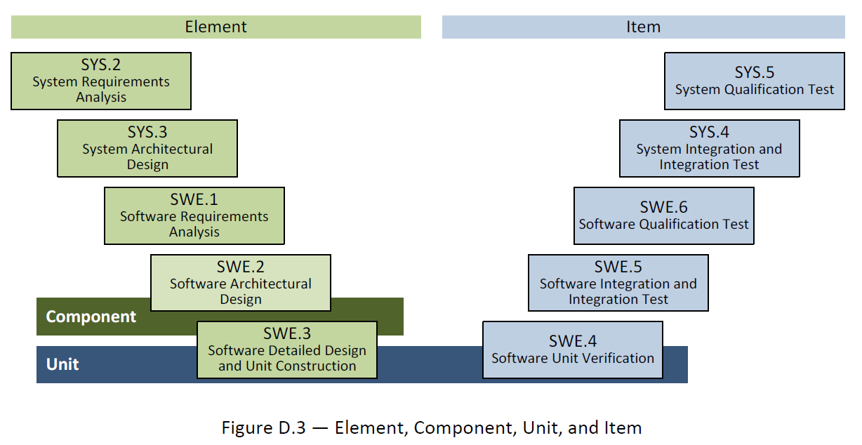
- The notice “LGE Internal Use Only” is for this template itself. The document which use this template needs to be classified as suitable security level according to its content.

General Guidelines
- Ground Rules for SWUTP
- This Software Unit Test Plan for each test area is to validate each development area.
That is, the targets and criteria for testing areas are planned based on the corresponding development areas.
- TMP is tailoring in consultation with concerned staff according to project status.
- Seven Rules
- Write from the reader's point of view..
- Avoid unnecessary repetition of information in the document.
- Make sure there is no ambiguity in the document. Clearly specify the meaning of the notation used in the diagram.
- Use the standard structure of the document. Create an easy-to-reference structure. Don't leave the blank for difficult parts and mark them "to be metered."
- Record the reasons for adopting the test. It is useful for future reviews or changes.
- Do not reflect the changes immediately on the document. Instead, reflect the changes according to the document's version control and release schedule.
- Ask the target reader for a review.
- References
This template has been revised by referring to the following test related technical data and the TMP template and guide document which have been distributed in the past.
- Automotive_SPICE_PAM_v3.0
- ISO/IEC/IEEE 29119 Software Testing Standard
- ISO/IEC/IEEE 25010:2011 Systems and Software Engineering
- Previously deployed TMP templates and guidelines from VS
- Document Format
If you use this template, you don't have to worry about document forms. Follow the basic rules below.
- Body font : Clear Gothic
- Give numbers and titles to all pictures and tables and make them easy to mention.
- Automatically insert captions : Select a figure or table from [Reference] > [Captition In] > [Label] in woad and select OK.
- Caption location :
Insert caption below picture : Figure 1 picture titl, Figure 2 picture titl, ..
Insert captions over table : Table 1 table title, Table 2 table title, ..
- Document Versioning, File Naming Rule
See the section 'Naming Rules for Document Output' in the Configuration Management Guideline (LGE_VS_Guideline_Form Management) managed within a project.
About This Document
Document Information
Issuing authority | VS OOO Team
Configuration ID | Configuration Item ID of CMBook
Status of document | In Progress / Approved / Released

Revision History
Write revision history.
Make sure that the latest contents are at the top.

Verion | Date | Comment | Author | Approver
#.# | YYYY-MM-DD | OOOOOOO | OOO | OOO

Purpose
Write about the purpose of this document.
This document is a test plan for the [Project Name].

Scope
Write about the scope of this document.
This document includes the following.
- Test strategy
- Test Scope
- Quality objectives
- Roles and Responsibilities
- Test methodology
- Test schedule
- Test output
- Measurement
- Regression test
- Test criteria
- Test environment
- Test constraints
- Test risk

Audience
Write a person to read this document.
The target audience for this document is as follows :
- Project Manager
- Project Leader
- Project Sub-leader
- SW Engineer
- HW Engineer
- Test Engineer
- Configuration Manager
- Requirement Manager

Related Documents
Write documentation related to the use of this document.
The documents related to this document are as follows:
- LGE_[OEM]_[Project name]_TMP
- LGE_[OEM]_[Project name]_SWUTP
- LGE_[OEM]_[Project name]_SWITP
- LGE_[OEM]_[Project name]_SWTP
- LGE_[OEM]_[Project name]_SysITP
- LGE_[OEM]_[Project name]_SysTP
- LGE_[OEM]_[Project name]_SWUTC
- LGE_[OEM]_[Project name]_SWITC
- LGE_[OEM]_[Project name]_SWTC
- LGE_[OEM]_[Project name]_SysITC
- LGE_[OEM]_[Project name]_SysTC
- LGE_[OEM]_[Project name]_PMP
- LGE_[OEM]_[Project name]_CMP
- LGE_[OEM]_[Project name]_CMBook
- LGE_[OEM]_[Project name]_WBS
- LGE_[OEM]_[Project name]_PRM

Conventions and Acronyms
Conventions
In this document, easy-to-know notes and important things you should know are as follows:

NOTE
A number of useful notes to keep in mind in text.

CAUTION
Important items must to know

Acronyms

Acronym | Description
TMP | Test Master Plan
SysTP | System Qualification Test Plan
SysT | System Qualification Test
SysITP | System Integration Test Plan
SysIT | System Integration Test
SWTP | Software Qualification Test Plan
SWT | Software Qualification Test
SWITP | Software Integration Test Plan
SWIT | Software Integration Test
SWUTP | Software Unit VerficiationPlan

Table of Contents
1 Plan Context 1-1
1.1 Test Item 1-1
1.2 Test Scope 1-1
2 Risk Register 2-2
2.1 Project Risks 2-2
2.2 Product Risks 2-2
3 Test Strategy 3-4
3.1 Test Process 3-5
3.2 Test Deliverables 3-5
3.2.1 Test Cases 3-5
3.2.2 Test Results Report 3-5
3.2.3 Test Plan 3-6
3.3 Reviews 3-6
3.3.1 Requirements Testability Review 3-6
3.3.2 Test Case Conformity Review 3-7
3.4 Test Design Techniques 3-7
3.4.1 Software Code Review 3-7
3.4.1.1 Offline review 3-8
3.4.1.2 Static analysis review 3-8
3.4.1.3 Review on Gerrit. 3-8
3.4.2 Static Testing 3-9
3.4.3 Specification Based Testing 3-10
3.4.3.1 Equivalence Partitioning (example) 3-11
3.4.3.2 Boundary Value Analysis (example) 3-11
3.4.4 Structure Based Testing 3-11
3.4.5 Experience Based Testing 3-11
3.5 Test Entry/Completion Criteria 3-12
3.5.1 Entry Criteria 3-12
3.5.2 Completion Criteria 3-12
3.6 Metrics to be collected 3-12
3.6.1 The Metrics of Measurement Analsysis 3-12
3.6.1.1 Statement Coverage (example) 3-12
3.6.2 The Metrics of Test Cases Develoment Plan 3-13
3.7 Retesting and Regression Testing 3-13
3.8 Test Data 3-13
3.9 Test Environment Requirements 3-13
3.9.1 Test Tools 3-13
3.9.1.1 SW Testing Tools 3-13
3.10 Suspension and Resumption Criteria 3-14
4 Schedule 4-15

Figures
Figure 3-1. Bidirectional Traceability and Consistency of A-SPICE PAM 3.0 3-4
Figure 3-2. Test Process 3-5
Figure 3-3. Requirements Testability Review 3-7
Figure 4-1. Workflow 4-15

Tables
Table 2-1 Project Risks 2-2
Table 2-2 Product Risks 2-3
Table 3-1 Gerrit Score 3-8
Table 3-2 Test Techniques of Specification Based Testing 3-10
Table 3-3 Test Techniques of Structured Based Testing 3-11
Table 3-4 Test Techniques of Experience Based Testing 3-12
Table 3-5 Entry Criteria 3-12
Table 3-6 Completion Criteria 3-12
Table 3-7 Metrics of Measurement Analysis 3-12
Table 3-8 Metrics of Test Cases Develoment Plan 3-13
Table 3-9 Test Data 3-13
Table 3-10 Software Testing Tools 3-14
Table 3-11 Suspension/Resumption Criteria 3-14

Plan Context

Test Item
Describe the outline of the Software Unit Test Item.
Visualize by inserting relevant Collab Link information.

Test Scope
The software unit area developed by LG is defined as Test Scope and explained.

Risk Register
The risk associated with the test should be derived from the predefined risk in the project.
If there is no definition, do not write it as optional.

Project Risks
※ Risk = Likelihood × Impact
※ Likelihood: 1 (Low), 2 (Medium), 3 (High) / Impact: 1 (Low), 2 (Medium), 3 (High)
ID | Project Risk | Likelihood | Impact | Risk Score | Mitigation Activities
P1 | Lack of testing skills
P2 | Manpower shortage
P3 | Education Issue
P4 | Poor quality design
P5 | Shipping delay such  as chipset
P6 | Supply and demand  problems of suppliers
P7 | Not enough testing  schedule
P8 | Delayed build of test  environment
P9 | Development delay of test data
P10 | …

Table 2-1 Project Risks

Product Risks
※ Risk = Likelihood × Impact
※ Likelihood: 1 (Low), 2 (Medium), 3 (High) / Impact: 1 (Low), 2 (Medium), 3 (High)
ID | Project Risk | Likelihood | Impact | Risk Score | Mitigation Activities
R1 | AAA (Complex features)
R2 | BBB (New development feature)
R3 | CCC (Large feature of Src Code)
R4 | DDD (Highly technical skill)
R5 | EEE (Applying the latest  technology)
R6 | FFF (Poor developer experience)
R7 | GGG (Features with high  external visibility)
R8 | HHH (Features that can be threatened by safety)
R9 | III (Strength is intense - light / intensity of sound)
R10 | JJJ (Features that big impact to company image)
R11 | …

Table 2-2 Product Risks

Test Strategy
Write about Software Unit testing strategies.

A-SPICE PAM 3.0 document says that each development level requires each testing.
- System Qualification Testing for System Requirements
- System Integration Testing for System Architecture
- Software Qualification Testing for Software Requirements
- Software Integration Testing for Software Architecture
- Software Unit Verification for Software Detailed Design

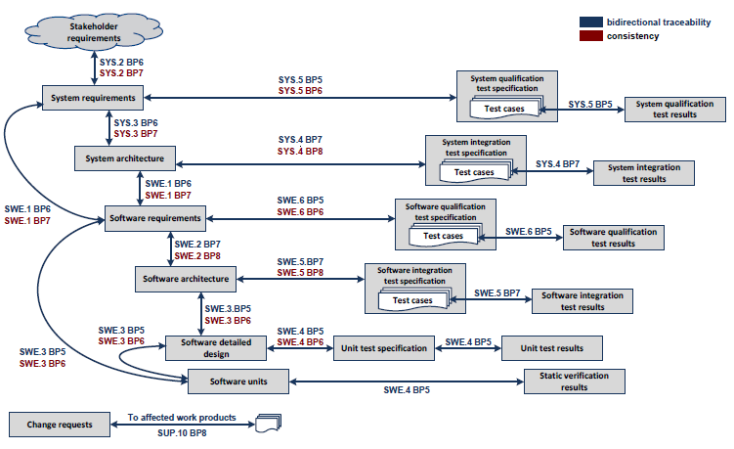
Figure 3-1. Bidirectional Traceability and Consistency of A-SPICE PAM 3.0

This project comply with A-SPICE test levels above.

The development schedule is composed of 9 releases, even though the goal is Release 7.
The duration of each iteration (release) would be as short as 3 months. Thus, Software Unit Verification should start and end at the same period of implementing. The basic testing of Software Integration is also done like SWUT. Then, 4 weeks are for testing the more specific Software Integration, Software Qualification, System Integration, and System Qualification, and 1 week for summarizing and reporting the test results.

Test Process
Write about Software Unit testing procedures.

The figure below depicts the testing overview of how to test.

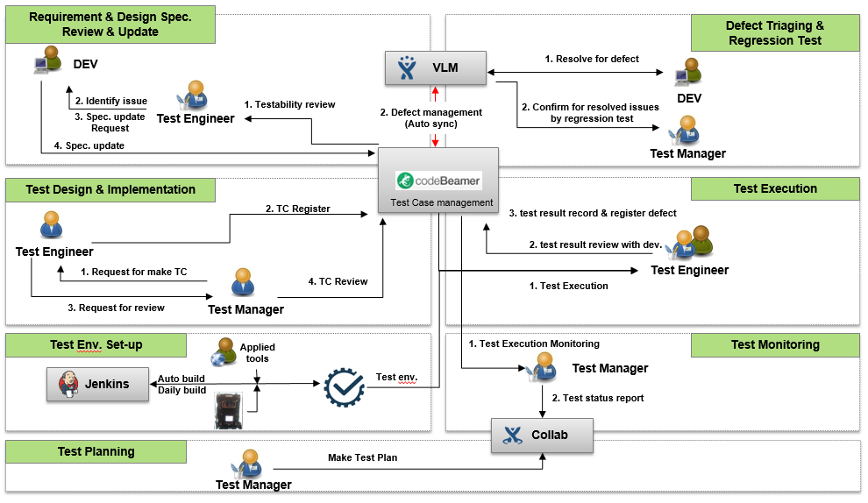
Figure 3-2. Test Process

Test Deliverables

Test Cases
Create a location of Test Case document for the Software Unit test.
http://val.lge.com/ivi/svn/DAI_MPC5_5/trunk/03_SW_Engineering/04_Test/02_SW_Unit_Veification/02_SW_Unit_Verification_Case

Test Results Report
Create a Software Unit Test Results Report Document Locations.
http://val.lge.com/ivi/svn/DAI_MPC5_5/trunk/03_SW_Engineering/04_Test/02_SW_Unit_Veification/03_SW_Unit_Verification_Report

http://val.lge.com/ivi/svn/DAI_MPC5_5/trunk/03_SW_Engineering/04_Test/02_SW_Unit_Veification/04_SW_Unit_Verification_Static_Analysis_Report

Test Plan
Create a storage location for this document.
http://val.lge.com/ivi/svn/DAI_MPC5_5/trunk/03_SW_Engineering/04_Test/02_SW_Unit_Veification/01_SW_Unit_Verification_Plan

Reviews

Requirements Testability Review
Write the necessary processes, tools, and checklist for conducting a testability review.
Write the Review Technologies (Walkthrough / Technical Review ...) to be applied at the time of technical document review.
The figure below depicts the overview of revewing requirements testability.
Test Manager and tets engineers review the draft documents written by the development teams with the checklists.

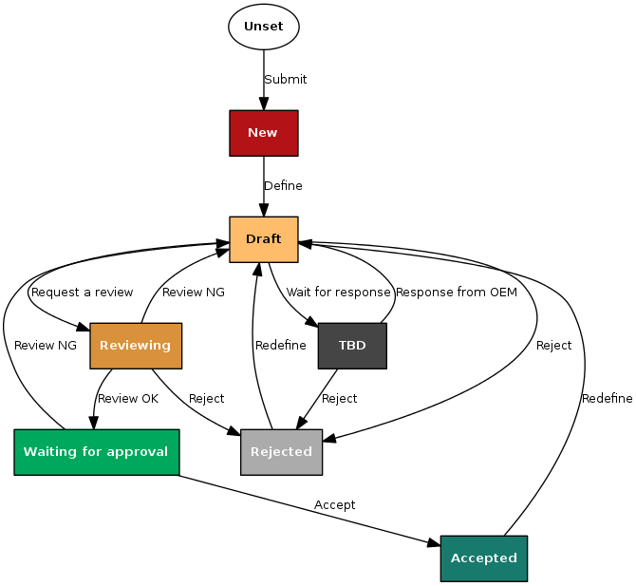
Figure 3-3. Requirements Testability Review

Test Case Conformity Review
Create the necessary processes, tools, and checklists for the Test Case Conformity Review
Write a Review Techniques (Peer-review ...) to be applied when a Test Case Review.

Test Design Techniques

Software Code Review
Write about how to review the software code.
After reviewing with the developer or function owner in off-line, proceed on-line review.
There are two kinds of offline review, a self-rewiev that each developer directly performs and a pair-review that is performed by the function owner. And they are performed regularly. Online review is conducted according to the in-house gerrit review policy. The gerrit review policy for the project can be found at:
http://collab.lge.com/main/display/DAIMPC/3.+Gerrit+code+review+on+MPC5.5+project

When all of the source codes are checked in the configuration management system called
‘GIT’, code review is performed with review system, Gerrit.

Offline review
Engineers checks below items before commit.
This commit obeys the SW detailed design's following items.
(Y) Name of files, classes, functions, parameters and variables.(If exists)
(Y) Type of returns, parameters and variables.(If exists)
(Y) Access modifier for members.- functions and variables (If exists)
(Y) Dynamic design and algorithm.
(Y) All contents without omission.

The function owner verifies the SW code of the sub-developers according to the in-house code review standard.
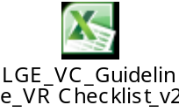

Static analysis review
Code review for static analysis is conducted according to LG Electronics VS codereview policy. The contents of the Code Reiview can be found below.

http://collab.lge.com/main/pages/viewpage.action?pageId=624025714

Review on Gerrit.
Each commit scored by person and automatic systems (jenkins, reviewer). Gerrit has three kinds of point like below,
Score | Means | By who | Action.
+1 | No problem. | Jenkins | It needs review again.
+2 | Ready to merge. | Reviewer | It will be merged in next build.
-1 | Problems exist.. | Jenkins | It will not be merged.
Table 3-3 Gerrit Score
a. jenkins
Jenkins checks build verification. As soon as commit occurs, Jenkins builds new software with new commit. Jenkins scores like belows.
+1: build success.
-1: build fails

b. reviewer
Reviewers check that a commit obeys SW detailed design. Without reviewer’s review, new commit never be merged.
+1: the code checked, but it needs review again,
+2: the code checked finally, so it needs be merged.
-1: the code have problem.

Static Testing
Write a static test execution method.

In this project, SW Static Analysis is carried out through the following activities.
1. Build a server pc and environment that can run static analysis by request to your in-house SW infrastructure team.
2. Validation once a week using Coverity Tool based on in-house static analysis rules, MISRA C 2012, MISRA CPP 2008 rules (publish report every Friday)
3. Issue an automatic notification to the function person in charge of the violation
4. Check whether the status meets the target value for corresponding release

Refer to the external document for more information
http://collab.lge.com/main/display/DAIMPC/SWE.4+Guide

As a part of continuous integration system, static analysis is periodically performed with the tool ‘Coverity’. Static analysis results will be periodically tracked and managed by sending notifications to SW engineers and PL. And also anyone can check code quality status through website report of build server . Website all required error types - division by zero, overflows, value range violations, infinite loops, type mismatches, initialization errors, unauthorized access, unreachable source code. In addition to the required error types, LG also detects other error types such as incorrect expression, no effect, null pointer dereferences, bad free and etc. Enabled Coverity v8.6 checkers are attached below. Enabled checkers may become a little bit different from the attached file, according to coverity support roadmap or internal policy.
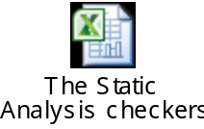

Coverity can also report violations of rules specified by the MISRA C-2012, MISRA C++-2008 standards. Depending on the requirements, the scope of the MISRA C-2012 and MISRA ++ 2008 rulesets for static analysis is determined. Please refer to the following address.
http://collab.lge.com/main/pages/viewpage.action?pageId=616129785

MISRA C 2012 and MISAR CPP 2008 can be found in the attached document below. Validation is also analyzed through Coverity v8.6.
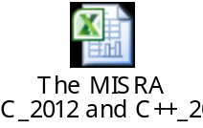

LG’s overall process of static analysis, workflows and defect life cycles are below site.
http://collab.lge.com/main/pages/viewpage.action?pageId=623686533

When ignoring high impact defects, there should be proper reason and they should be confirmed by the reviewer. Also, the policy to ignore high impact defects is as follows.
- incorrect ignore reason = 0 : When Ignore a defect, Ignore Reason, Action_Developer that matches the Classification must be entered.
- no peer-review = 0 : It should be double checked by reviewer.
- 'Action_Reviewer' = 'Ignore confirmed', 'Reviewer' = 'Reviewer’s AD account'
self-review = 0 : Other Reviewer from owner needs to double check. ('Reviewer' != 'Owner')

Specification Based Testing
Write a method of performing specification-based tests.

Test Technique | Applicable (Y or N) | Remarks
Equivalence Partitioning
Boundary Value Analysis
Decision Table Testing
State Transition Testing
Combinatorial Testing
Scenario Testing
Test Techniques of Specification-Based Testing

Test Technique | Applicable (Y or N) | Remarks
Equivalence Partitioning
Boundary Value Analysis
Decision Table Testing
State Transition Testing
Combinatorial Testing
Scenario Testing
Table 3-4 Test Techniques of Specification Based Testing

Equivalence Partitioning (example)

Boundary Value Analysis (example)

Structure Based Testing
Write a structure-based test method

Test Technique | Applicable (Y or N) | Remarks
Statement Testing
Decision Testing
Branch Testing
Branch Condition Testing
(All) Path Testing
Control Flow Testing
Test Techniques of Structure-Based Testing

Test Technique | Applicable (Y or N) | Remarks
Statement Testing
Decision Testing
Branch Testing
Branch Condition Testing
(All) Path Testing
Control Flow Testing
Table 3-5 Test Techniques of Structured Based Testing

Experience Based Testing
Write a experiance-based test method

Test Technique | Applicable (Y or N) | Remarks
Ad-hoc Testing
Exploratory Testing
Scripted Testing
Test Techniques of Experience-Based Testing

Test Technique | Applicable (Y or N) | Remarks
Ad-hoc Testing
Exploratory Testing
Scripted Testing
Table 3-6 Test Techniques of Experience Based Testing

Test Entry/Completion Criteria

Entry Criteria
Write the entry criteria for the Software Unit test.

Criteria
Every code commit
SW unit implementation complete
Table 3-7 Entry Criteria

Completion Criteria
Write the completion criteria for the Software Unit test

Completion Criteria
R1 | R2 | R3 | R4 | R5 | R6 | R7
 |  | 30% | 50% | 70% | 90% | 100%
Table 3-8 Completion Criteria

Metrics to be collected
See the Measurement Analysis Report in more detail.
(http://val.lge.com/ivi/svn/DAI_MPC5_5/trunk/02_Management/10_Quality_Measurement).

The Metrics of Measurement Analsysis
Write the measurement metircs for Software Unit test.

Statement Coverage (example)

SW Interface Coverage
R1 | R2 | R3 | R4 | R5 | R6 | R7
 |  | 30% | 50% | 70% | 90% | 100%
Table 3-9 Metrics of Measurement Analysis

The Metrics of Test Cases Develoment Plan
Write the software unit test test case preparation plan metrics.

Test Cases Development Plan
R1 | R2 | R3 | R4 | R5 | R6 | R7
 |  | 30% | 50% | 70% | 90% | 100%
Table 3-10 Metrics of Test Cases Develoment Plan

Retesting and Regression Testing
Write the Regression test cycle setting (e.g. Conducting a Regression Test after three retests) and retesting cycle setting.

Test Data
Write about Software Unit test data.

Test Data | Description
Table 3-11 Test Data

Test Environment Requirements
Write about the Software Unit test environment.

Test Tools

SW Testing Tools
Write the SW tools used in the SW Unit test.

The test environment requirements for the SW unit test are shown in the table below.
The following table shows the environment requirements required for SW unit verification.

GP side SW Unit Verification Environment Requirements

Item | Description | Remark
Software Code Review | OS: Linux 64bit  Tool : Gerrit | Ver 2.13.7
Static Testing | OS: Linux 64bit  Tool : Coverity | Ver 8.6
Specification Basd Testing | OS: win7 64bit  Tool : Controller Tester | Ver 2.9.2
Structure Based Testing | OS: win7 64bit  Tool : Controller Tester | Ver 2.9.2
Experience Based Testing | OS: win7 64bit  Tool : Controller Tester | Ver 2.9.2
Table 3-12 Software Testing Tools

Suspension and Resumption Criteria
Write about suspension and resumption criteria of the Software Unit test.

Step | Criteria
Suspension | Cases that Source code and design output do not match or  Source code have an issue. And automation system finds build issues. (commit scores -1)  When critical defects or major defects occur such that there is a disruption in the overall test progress, the test manager should share the situation with the PL and major stakeholders and decide whether to stop the test by conducting a meeting to determine whether to discontinue the test.
Resumption | Cases that new patch-set with modified code. The test manager decides whether to resume the test through consultation with the relevant parties after the completion of the critical defect resolution.
Table 3-13 Suspension/Resumption Criteria

Schedule
Write about the software test schedule.
If the schedule has already been detailed in the Feature Release Plan or WBS, refer to the document.

http://val.lge.com/ivi/svn/DAI_MPC5_5/trunk/02_Project Management/03_WBS/LGE_DAI_MPC5.5_WBS_v1.0.mpp

The workflow of the process is as follows.

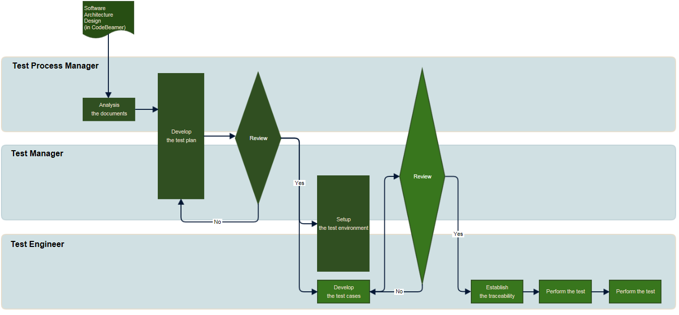
Figure 4-4. Workflow
Details can be found at the following address.
http://collab.lge.com/main/display/DAIMPC/SWE.5+Workflow

The SW Release Plan can be found at the following address.
http://val.lge.com/ivi/svn/DAI_MPC5_5/trunk/02_ProjectManagement/00_Guide&milestone/02_Project Milestone/LGE_DAI_MPC5.5_SW_Release_Build_Plan_All_v1.0a.xlsx

